# User Manual

1. Install xampp on your pc.
2. Open xampp.

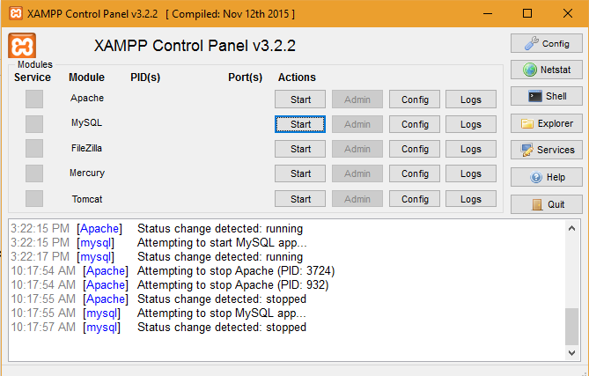

1. Click on start Apache and MySQL

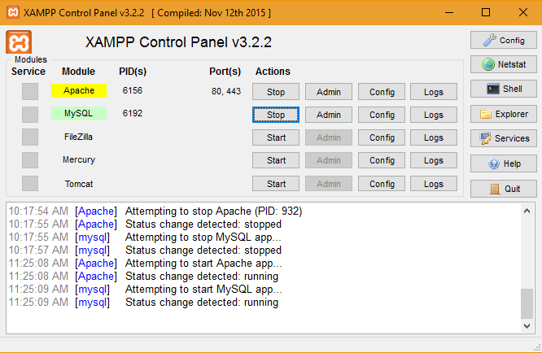

1. Click on admin against MySQL from xampp.
2. It will open MySQL manager in the browser then create a data base named hms and import structure of database from hms.sql file present in the folder

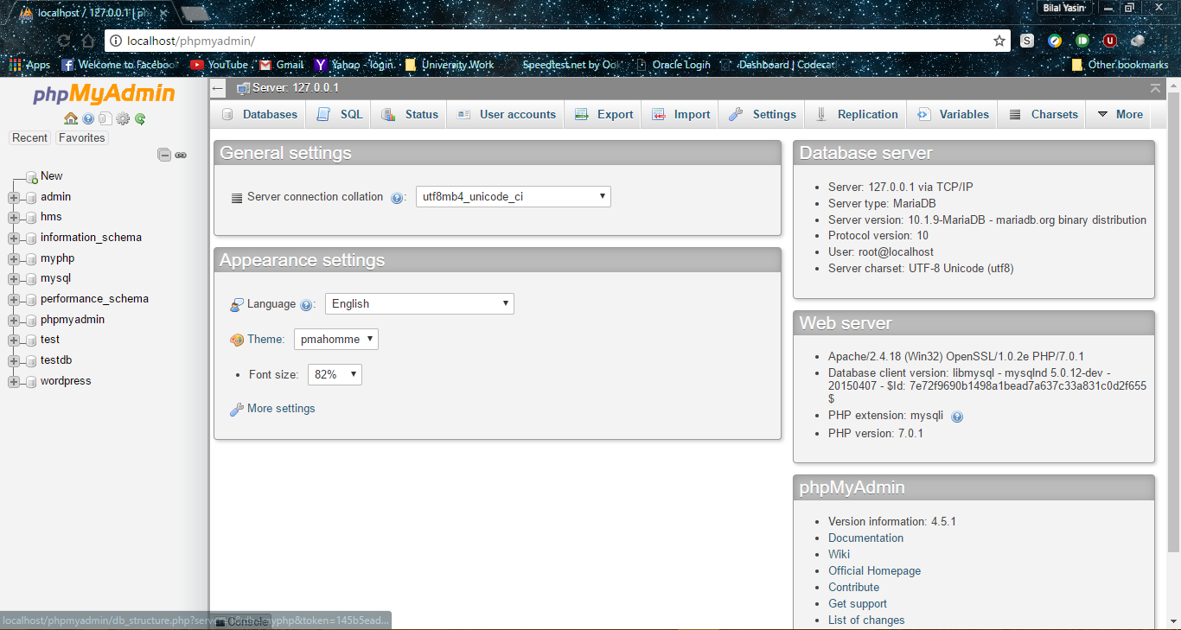

1. Copy the hms folder to c:/xampp/htdocs folder
2. Open browser and enter url “localhost/hms”

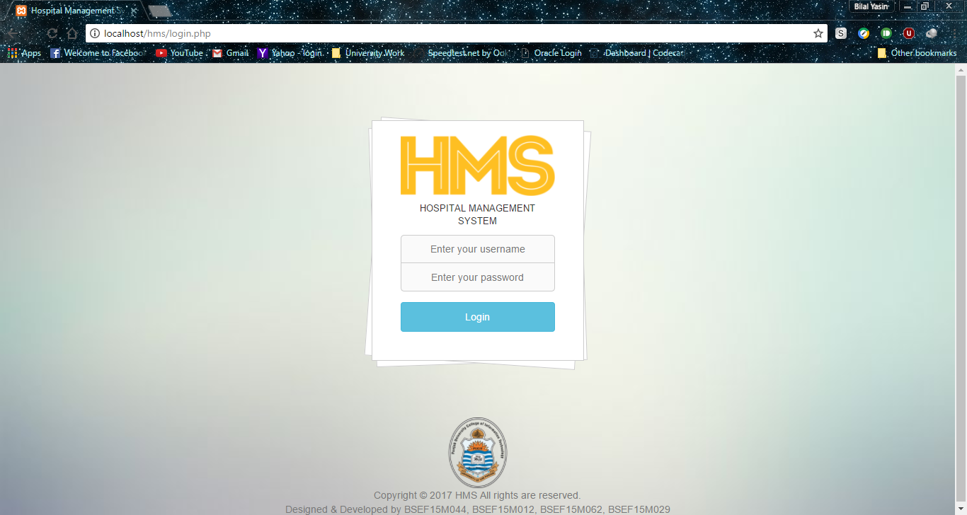

1. Login screen will appear enter desired login and passwords given in the Readme.txt file.